Using Noodle Tools to create a
Works Cited or Bibliography

Go to http://www.noodletools.com

1. Enter your class login information and click “sign in.”

Personal ID: lazzaro Personal ID: belle5 Personal ID: blackmur
Password: shill Password: shill Password: shill

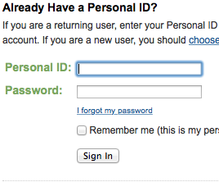

2. Once you are signed in Click on “Create a New Project” in the upper right hand corner.

3. You will be asked to fill in two bubbles, and to name your project. For the bubbles choose:
- MLA
- Starter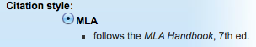

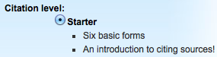

For Description type:
- Your Name
- Your Person’s Name you are studying
Example: Ms Ball Annie Jump Cannon
Then click “Create Project”
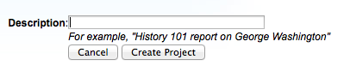

4. Once you click “Create Project” you will find yourself in an area called “Dashboard.” Scroll to the top of the page and click “Bibliography”

5. You will notice a drop-down bar that asks you to “Select a citation type.” Click on the two arrows and choose which resource you would like to cite.

To cite Grolier, Worldbook or Pebble Go choose “Database”
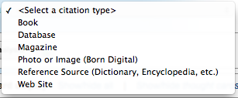

Once you select your citation type, click “Create Citation.”

6. This will lead you to a page where you will fill in the blanks with information about the source you used. If you can’t remember the information needed to fill in the blanks
- open Worldbook, Pebble Go or Grolier in another tab
- look up the article you used to take notes
- use the information to fill in the blanks for your citation
- when the citation is complete click “Submit” at the bottom.

